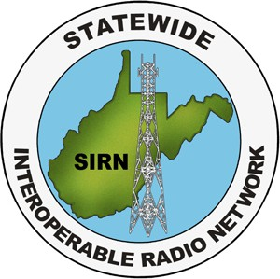
Statewide Interoperable Radio Network (SIRN)
APX Initial Programming Class
Course (ID#)
Jefferson County Emergency Communications Center 28 Industrial Blvd #100
Kearneysville, WV 25430

May 15, 2026, starting at 8:00 am
Description: This class provides hands-on and lecture-based training for WVSIRN Motorola APX Initial Programming for first time programmers or those needing recertification.

This course is for one day and is limited to 20 students.

Prerequisites: To attend this course, applicants must have the following prerequisites:

- IdentoGo/Idemia FBI Background check
  - An affidavit stating a background check has been recently completed with no concerns from the authority for which the applicant is employed or will be programming for may be accepted.
  - NOTE: If an affidavit or an Idemia/IdentoGo affirms any history, the applicant must present the background check information for review
  - Any results from background check results, regardless of method, will be reviewed by the SIEC prior to the applicant being allowed to attend a class.
- A signed security agreement with the appropriate jurisdiction umbrella under which they will be programming
  - Existing programmers will not need additional paperwork unless they are programming for a new jurisdiction, in which case they will also need a signed security agreement.
- Students need to come with the latest version of Motorola APX CPS installed prior to class. Programming software will not be distributed by the instructor.

Registration: To attend this course, applicants must register though wvpst.org first, then send scanned copies of all prerequisite documents, to Dustyn McConnell at swic@wv.gov. Copies of prerequisite documentation which verify applicants have met the prerequisites and are eligible to participate in the course must be submitted and reviewed at least ten (10) days prior to the course start date.

Registration is not complete until all documentation has been received and verified. Admittance is limited to 20 qualified applicants. Dustyn McConnell will notify applicants when they are registered.

If more than 20 qualified personnel apply, final determination of student attendance will be based on earliest registrations receive priority.

Cost: There is no cost to attend the course. Any costs incurred by attendee’s are the responsibility of the attendee or their sponsoring agency.

