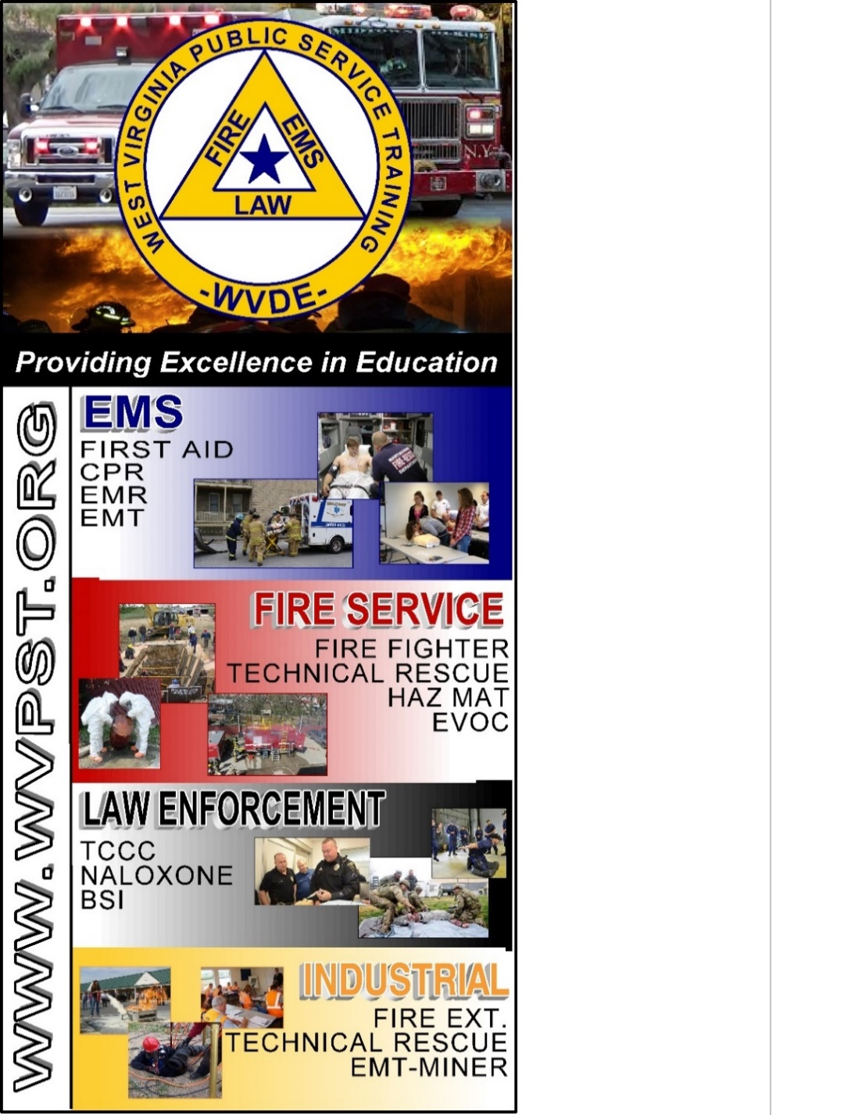

**ADVANCED MEDICAL LIFE SUPPORT (AMLS)**

**WVPST COURSE OFFERING**

**LOCATION: Capon Bridge Rescue Squad**

**WWW.WVPST.ORG**

**START DATE: April 6 -7, 2024**

**TIMES: 8AM – 4PM**

**INSTRUCTOR: Travis Combs   
  
HOURS: 16**

***Prerequisites: Must have current ALS or BLS provider certification*  
CLASS COST: $60.00  
BOOK COST: $62.00  
*(All students are required to have a book)***

**Pre-registration required online at** [**www.wvpst.org**](http://www.wvpst.org)**. Select Martinsburg and click on the class in the calendar. Minimum of 15 students required.**

**Contact WVPST at 304-267-3595 ext. 116**