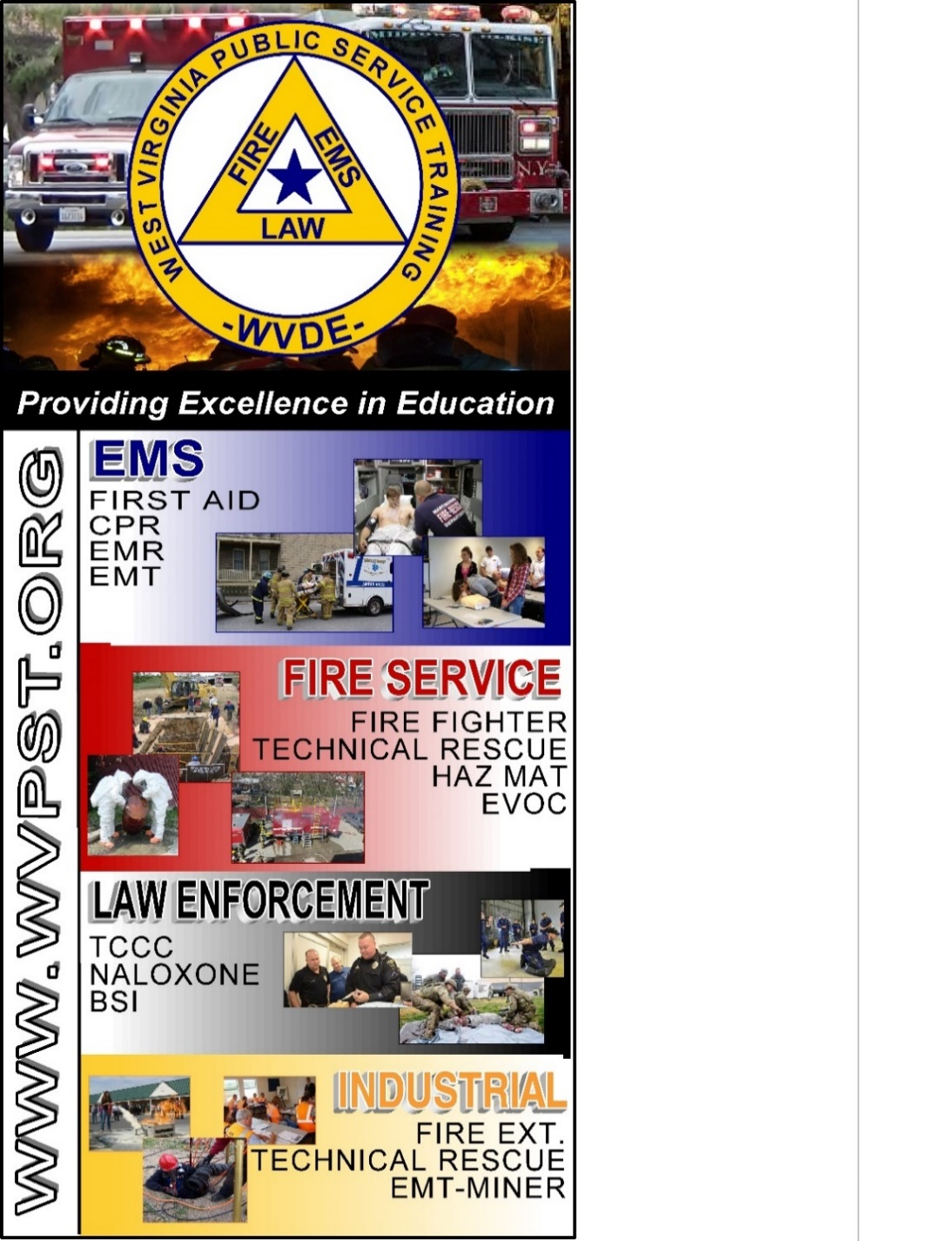

**DATES:  
October 11 – 12, 2025**

**TIME:   
9am – 5pm**

**INSTRUCTOR: Roger Brafford  
  
HOURS: 16**

**PREREQUSITE: Vehicle Operations-Passenger or Vehicle and Machinery Level I  
CLASS COST: $50.00  
BOOK COST: $85.00  
*(All students are encouraged to have a book)***

**Pre-registration required online at** [**www.wvpst.org**](http://www.wvpst.org)**. Select Martinsburg and click on the class in the calendar. Minimum of 15 students required.**

**Contact WVPST at 304-267-3595 ext. 116**

**Vehicle Rescue Technician   
- Passenger -  
  
Awareness, Operations, Technician**

**WVPST – Martinsburg COURSE OFFERING**

**LOCATION: Capon Bridge VFD**

**WWW.WVPST.ORG**