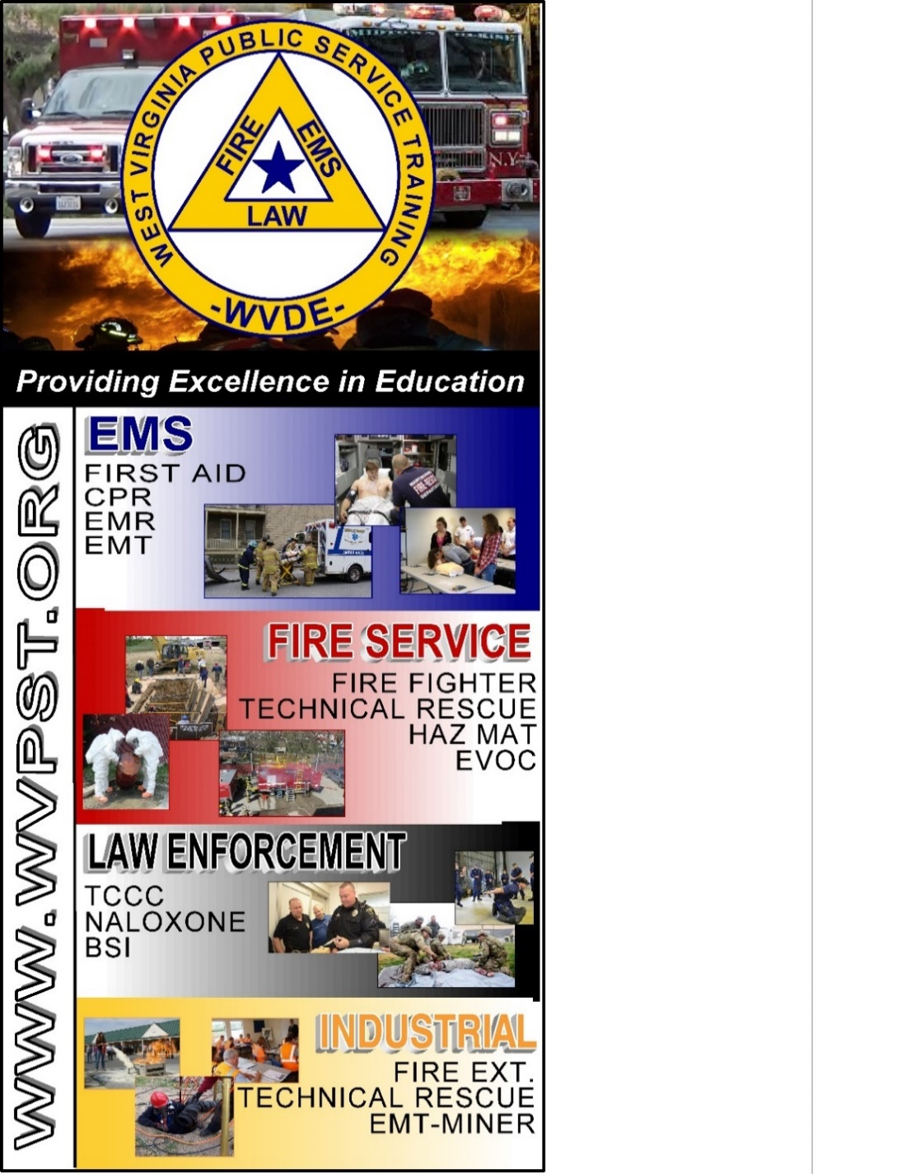

**Vehicle Rescue Awareness and Operations - Passenger  
  
Awareness, Operations, Technician**

**WVPST – Martinsburg COURSE OFFERING**

**LOCATION: Capon Bridge VFD**

**WWW.WVPST.ORG**

**DATES:  
September 20 – 21, 2025**

**TIME:   
8am – 6pm**

**INSTRUCTOR: Roger Brafford  
  
HOURS: 20**

**CLASS COST: $60.00  
BOOK COST: $85.00  
*(All students are encouraged to have a book)***

**Pre-registration required online at** [**www.wvpst.org**](http://www.wvpst.org)**. Select Martinsburg and click on the class in the calendar. Minimum of 15 students required.**

**Contact WVPST at 304-267-3595 ext. 116**