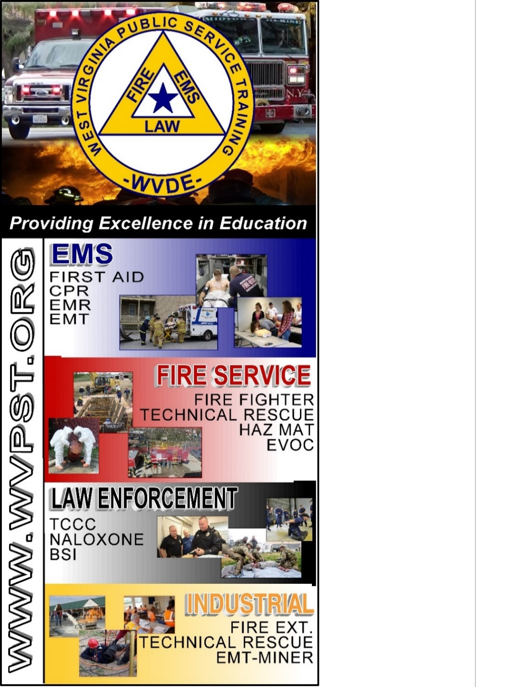

**WVPST COURSE OFFERING**

**LOCATION: Morgan County Rescue Squad**

**WWW.WVPST.ORG**

**START DATE: April 20, 2023  
TIME: 6pm**

**Classes meet Tuesdays and Thursdays at 6pm. Weekend requirements will be addressed in the class.**

**INSTRUCTOR: Jonathan Fink  
  
HOURS: 155**

***Class Cost: FREE*  
 Cost will be covered under grant obtained by Morgan County   
*(All students are required to have a book)***

**Pre-registration required online at** [**www.wvpst.org**](http://www.wvpst.org)**. Select Martinsburg and click on the class in the calendar. Minimum of 15 students required.**

**Contact WVPST at 304-267-3595 ext. 116**

**EMT - Initial**