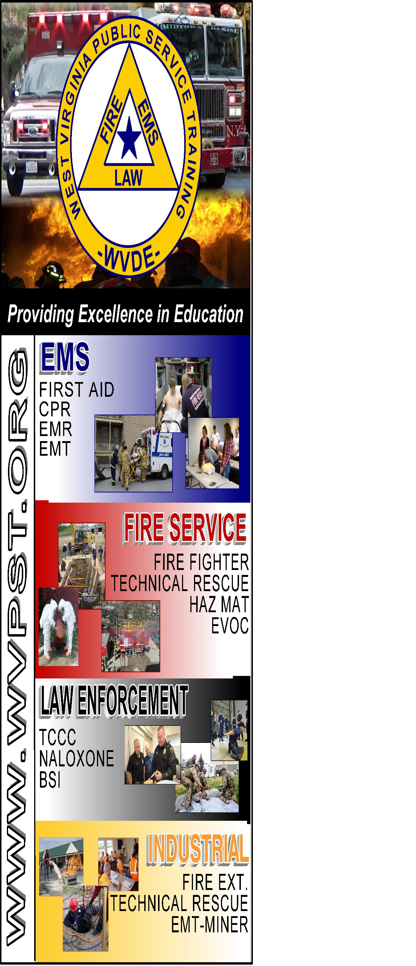

**WVPST COURSE OFFERING**

**Emergency Medical Technician**

**LOCATION: Fort Ashby VFC  
  
DATES and TIMES:**

**January 24, 2023 – 6pm**

**Class will be held Tuesdays and Thursdays from 6pm until 10pm**

**INSTRUCTORS:**

**Paula Detrick & Michael Lott**

**CLASS COST: $350.00  
BOOK COST: $220.00  
WORKBOOK: $75.00 *optional*  
*(All students are required to have a textbook)***

**Register online at** [**www.wvpst.org**](http://www.wvpst.org)**. Select Martinsburg and click on the class in the calendar.**

**Contact WVPST at 304-267-3595 ext. 116**