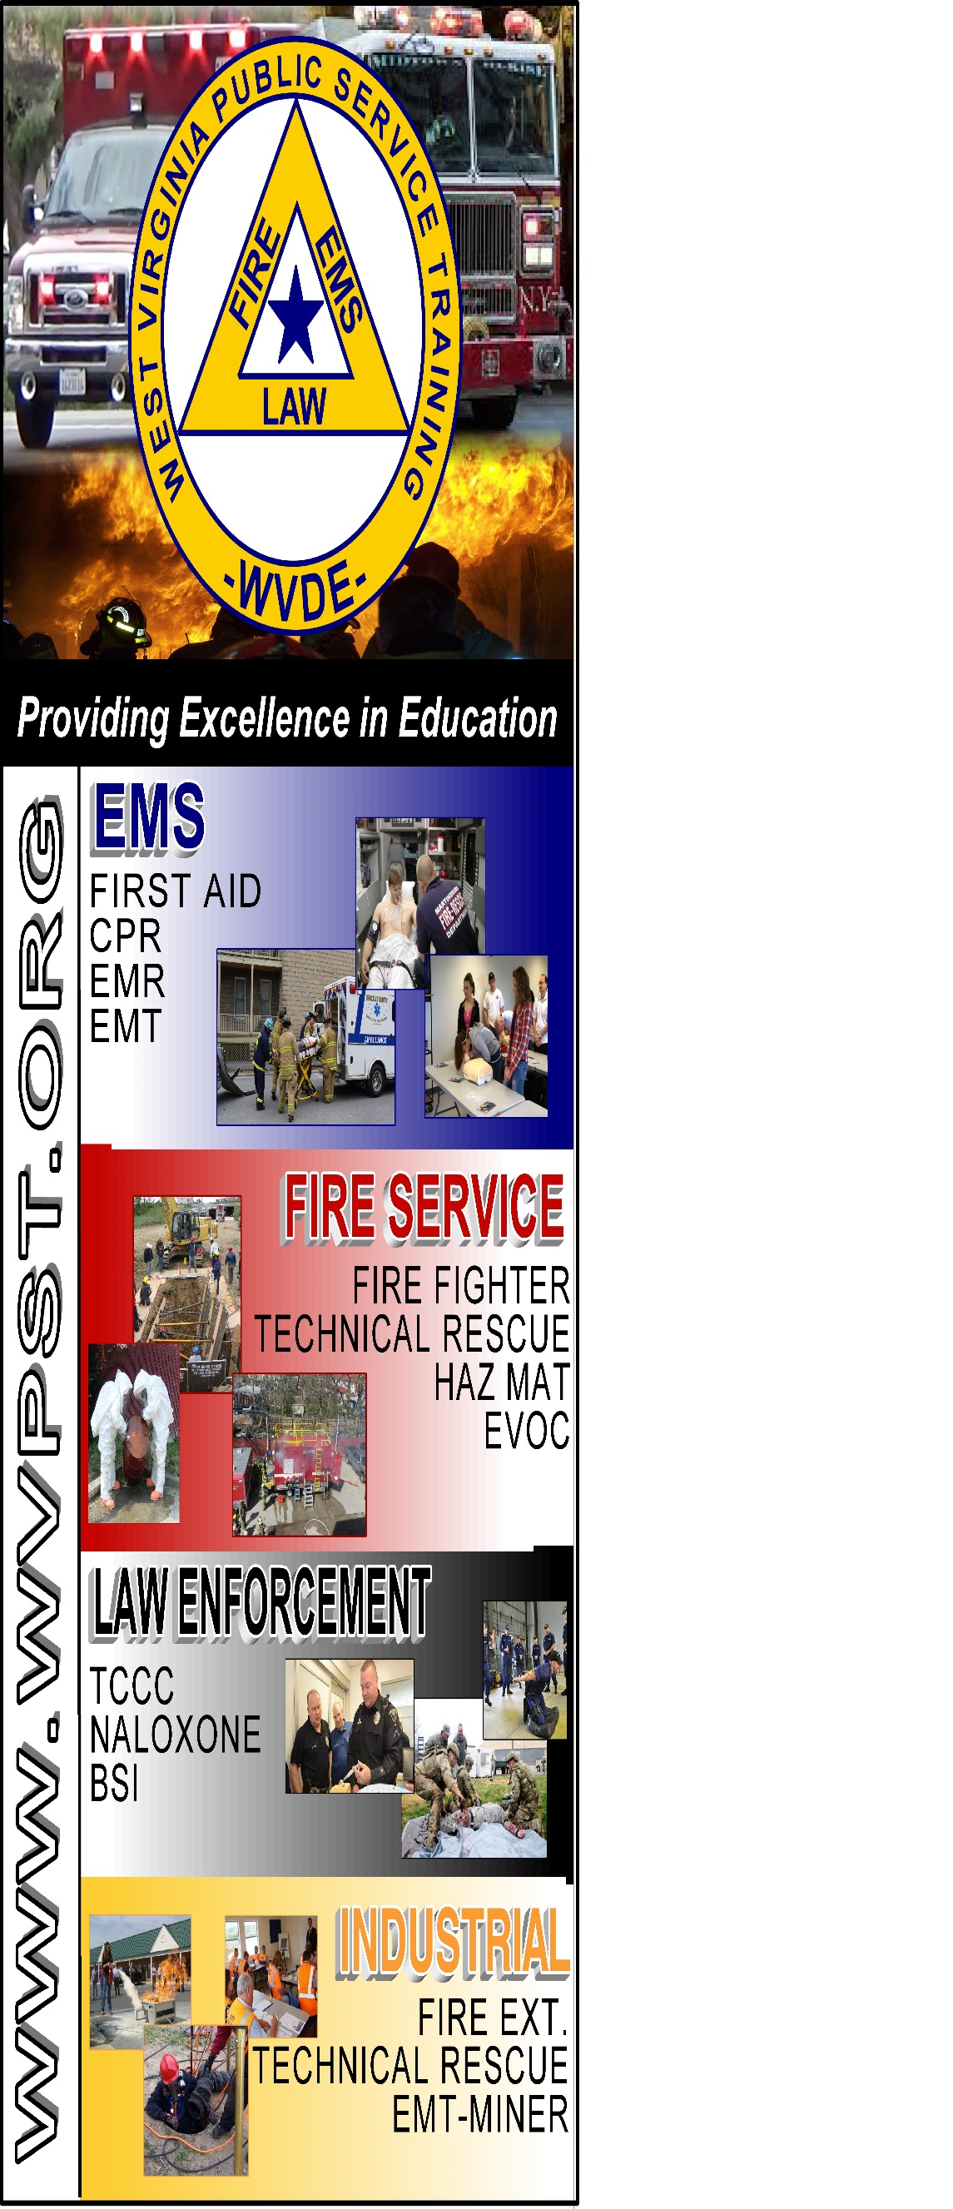

**WVPST COURSE OFFERING**

**EMT Refresher**

**LOCATION: New Creek VFD**

**DATES and TIMES:**

**October 29, 2022 – 9am - 9pm  
November 5, 2022 – 9am - 9pm**

**INSTRUCTOR: Craig Cox**

**HOURS – 24**

**CLASS COST: $50.00**

**Register online at** [**www.wvpst.org**](http://www.wvpst.org)**. Select Martinsburg and click on the class in the calendar.**

**Contact WVPST at 304-267-3595 ext. 116**