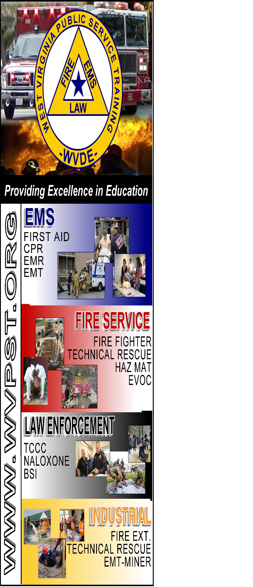

**WVPST COURSE OFFERING**

**EMT Refresher**

**LOCATION:**

**Upper Tract VFD Training Center**

**DATES and TIMES:**

**October 3,4,17,18 2022 – 5:30pm – 9:30pm  
October 23, 2022 – 1:00pm – 9:00pm**

**INSTRUCTOR: Michael Alt**

**HOURS – 24**

**CLASS COST: $50.00**

**Register online at** [**www.wvpst.org**](http://www.wvpst.org)**. Select Martinsburg and click on the class in the calendar.**

**Contact WVPST at 304-267-3595 ext. 116**