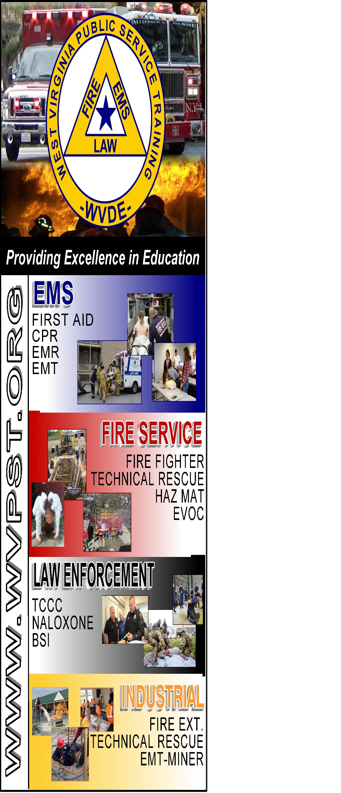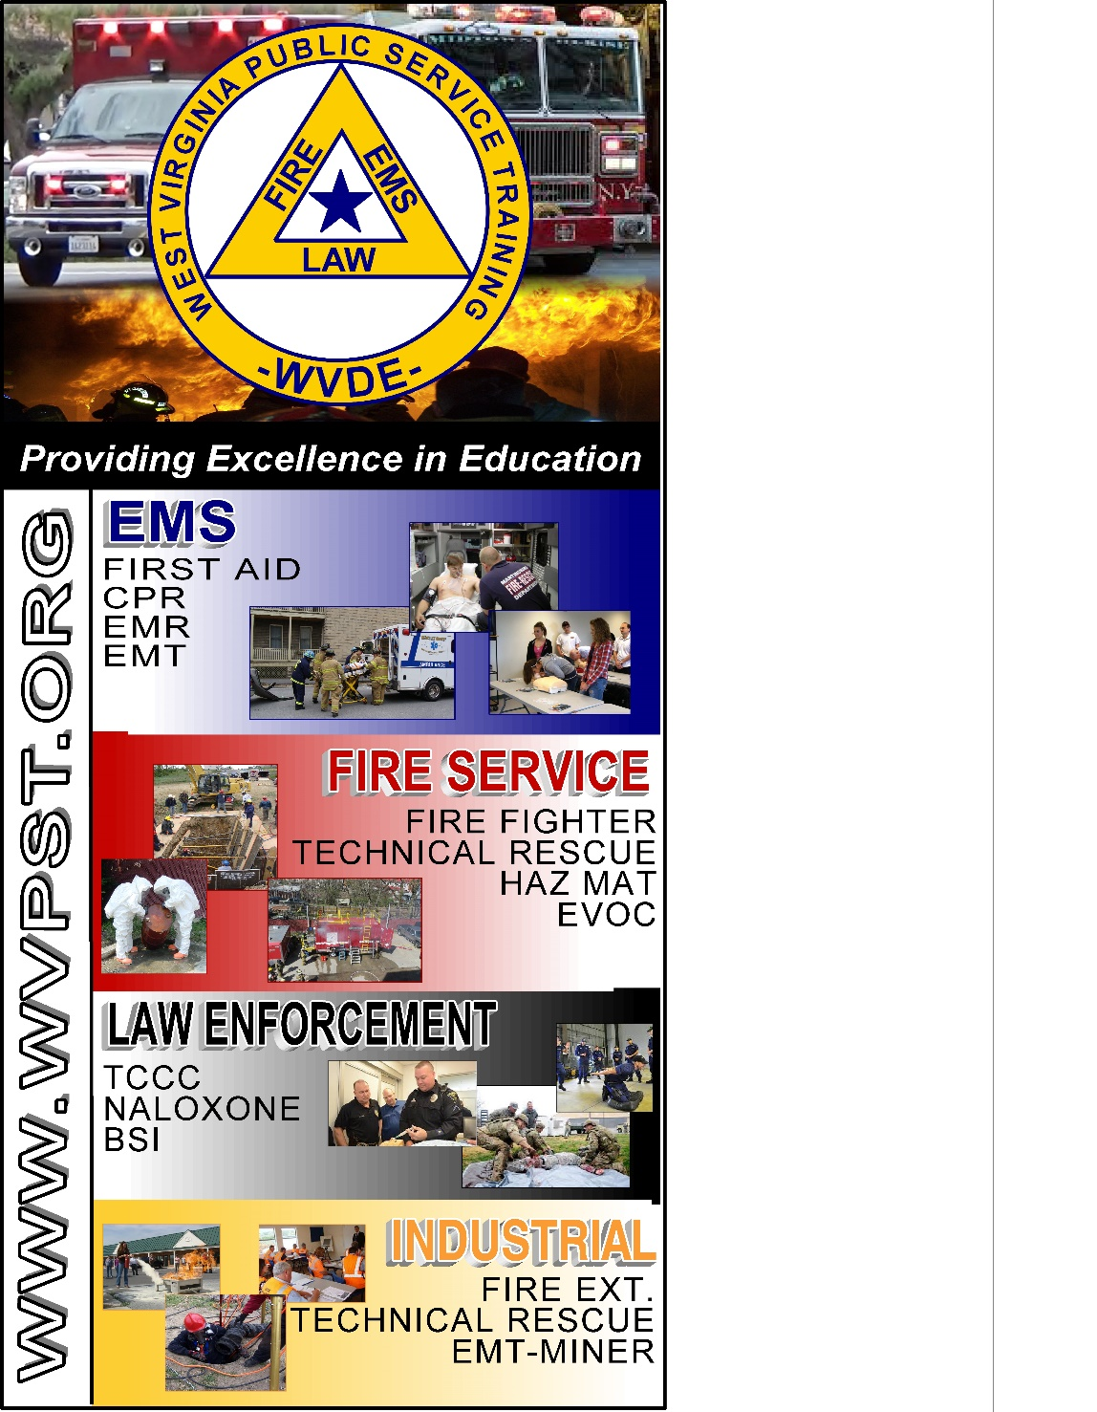

**WVPST COURSE OFFERING**

**Landing Zone Operations**

**LOCATION: Middleway VFC  
  
 DATE: August 8 – 6:30pm**

**There will be a classroom portion taught by Health Net personnel and helicopter will fly in around 7pm**

**INSTRUCTOR: Dennis Wilson  
  
HOURS: 4**

**Prerequisites: None**

**You can pre-register online at** [**www.wvpst.org**](http://www.wvpst.org)**. Select Martinsburg and click on the class in the calendar.**

**Contact WVPST at 304-267-3595 ext. 116**