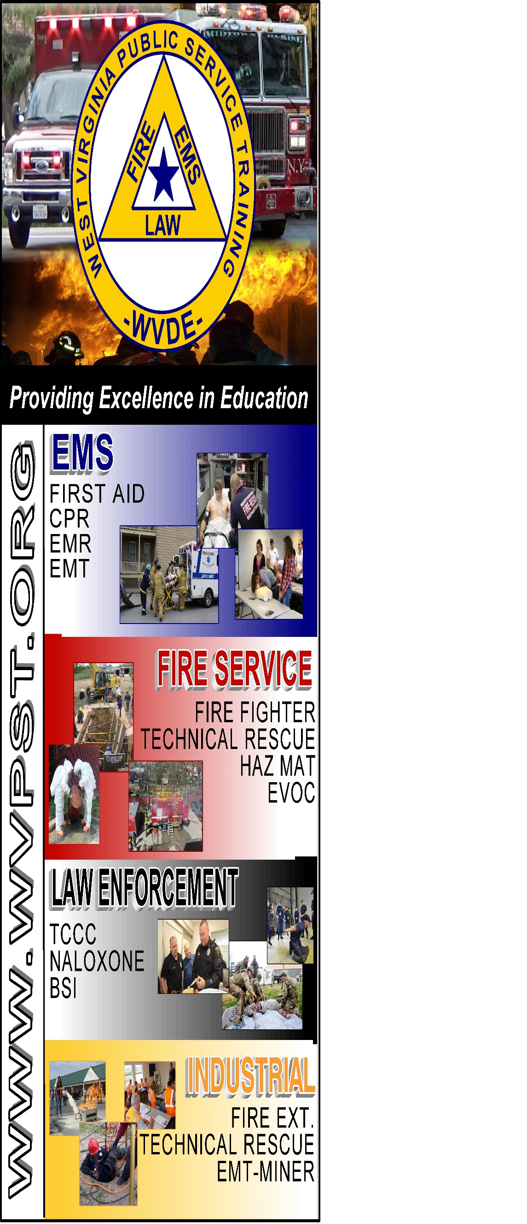

**WVPST COURSE OFFERING**

**EVOC**

**LOCATION: Wardensville Rescue Squad  
  
CLASS DATES: September 21 6-10**

**September 23 6-10**

**September 25 8am**

**Classes will meet the 21st and 23rd from 6pm-10pm**

**25th will start at 8am**

**INSTRUCTOR: Roger Brafford  
HOURS: 16**

***Prerequisites: Must be 18 years of age and hold a valid Driver’s License*   
CLASS COST: $35.00  
BOOK RENTAL: $10.00  
*(All students are required to have a book)***

**Pre-registration required online at** [**www.wvpst.org**](http://www.wvpst.org)**. Select Martinsburg and click on the class in the calendar. Minimum of 15 students required.**

**Contact WVPST at 304-267-3595 ext. 116**