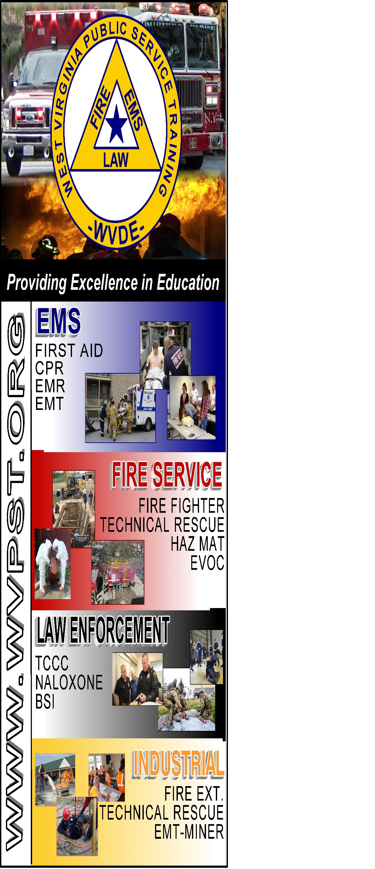

**WVPST COURSE OFFERING**

**Vehicle Rescue Technician**

**LOCATION: Capon Bridge Vol.**

**Fire Department   
  
CLASS DATES:**

**October 1 - 8am-5pm**

**October 2 - 8am-5pm**

**INSTRUCTOR: Roger Brafford**

**HOURS: 16**

***Prerequisites: Vehicle Rescue Operations*  
CLASS COST: $35.00  
BOOK COST: $80.00  
*(All students are required to have a book)***

**Pre-registration required online at** [**www.wvpst.org**](http://www.wvpst.org)**. Select Martinsburg and click on the class in the calendar. Minimum of 15 students required.**

**Contact WVPST at 304-267-3595 ext. 116**