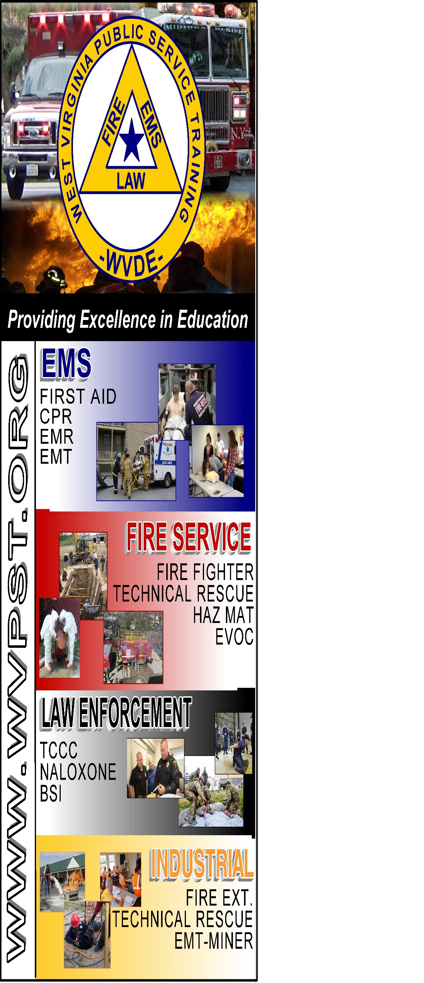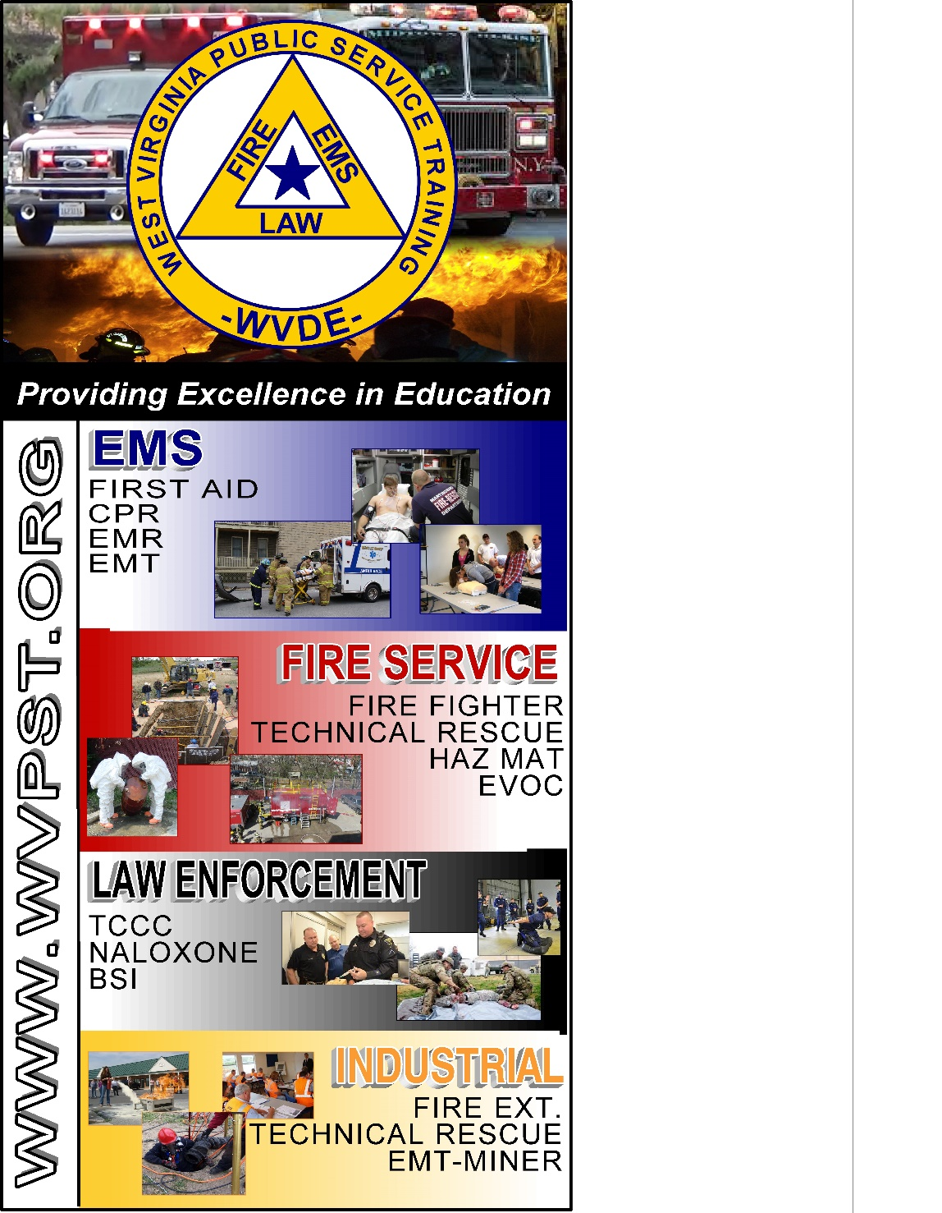

**WVPST COURSE OFFERING**

**Vehicle Rescue Awareness**

**LOCATION: Capon Bridge Vol.**

**Fire Department   
  
CLASS DATE: September 16, 2022**

**6pm – 10pm**

**INSTRUCTOR: Roger Brafford   
  
HOURS: 4**

***Prerequisites: None***

**CLASS COST: $35.00  
BOOK COST: $80.00  
*(All students are required to have a book)***

**Pre-registration required online at** [**www.wvpst.org**](http://www.wvpst.org)**. Select Martinsburg and click on the class in the calendar. Minimum of 15 students required.**

**Contact WVPST at 304-267-3595 ext. 116**