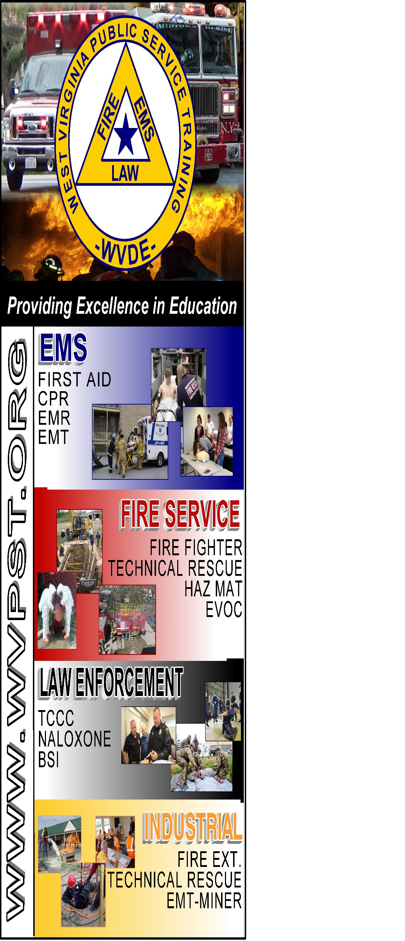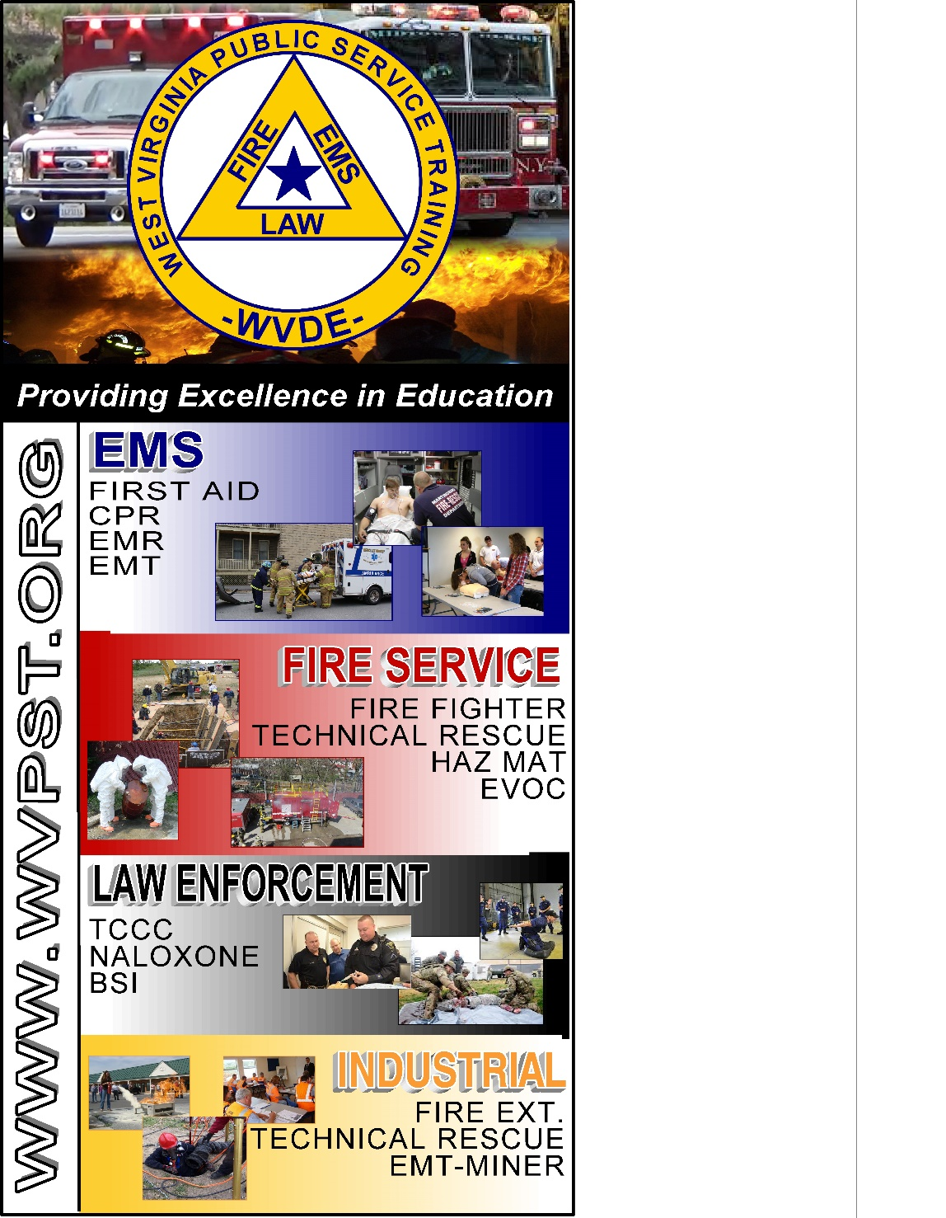

**WVPST COURSE OFFERING**

**Emergency Medical Technician Refresher**

**LOCATION: JCESA  
  
DATES and TIMES:**

**August 2, 2022 – 9am**

**Classes will be held August 2, 3 and 4 from 9am- 5pm.**

**INSTRUCTOR: Craig Horn**

**CLASS COST: $50.00**

**Register online at** [**www.wvpst.org**](http://www.wvpst.org)**. Select Martinsburg and click on the class in the calendar.**

**Contact WVPST at 304-267-3595 ext. 116**