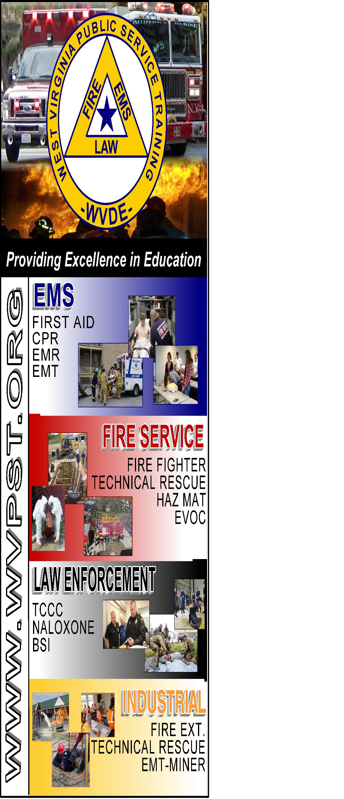

**WVPST COURSE OFFERING**

**Emergency Medical Technician**

**LOCATION: JCESA  
  
DATES and TIMES:**

**January 2, 2023 – 5:30pm**

**Classes will be Mondays and Wednesdays from 5:30pm to 10:00pm**

**INSTRUCTOR: Craig Horn**

**CLASS COST: $350.00**

**BOOK COST: $220.00**

**SUPPLY FEE: $50.00**

**Register online at** [**www.wvpst.org**](http://www.wvpst.org)**. Select Martinsburg and click on the class in the calendar.**

**Contact WVPST at 304-267-3595 ext. 116**