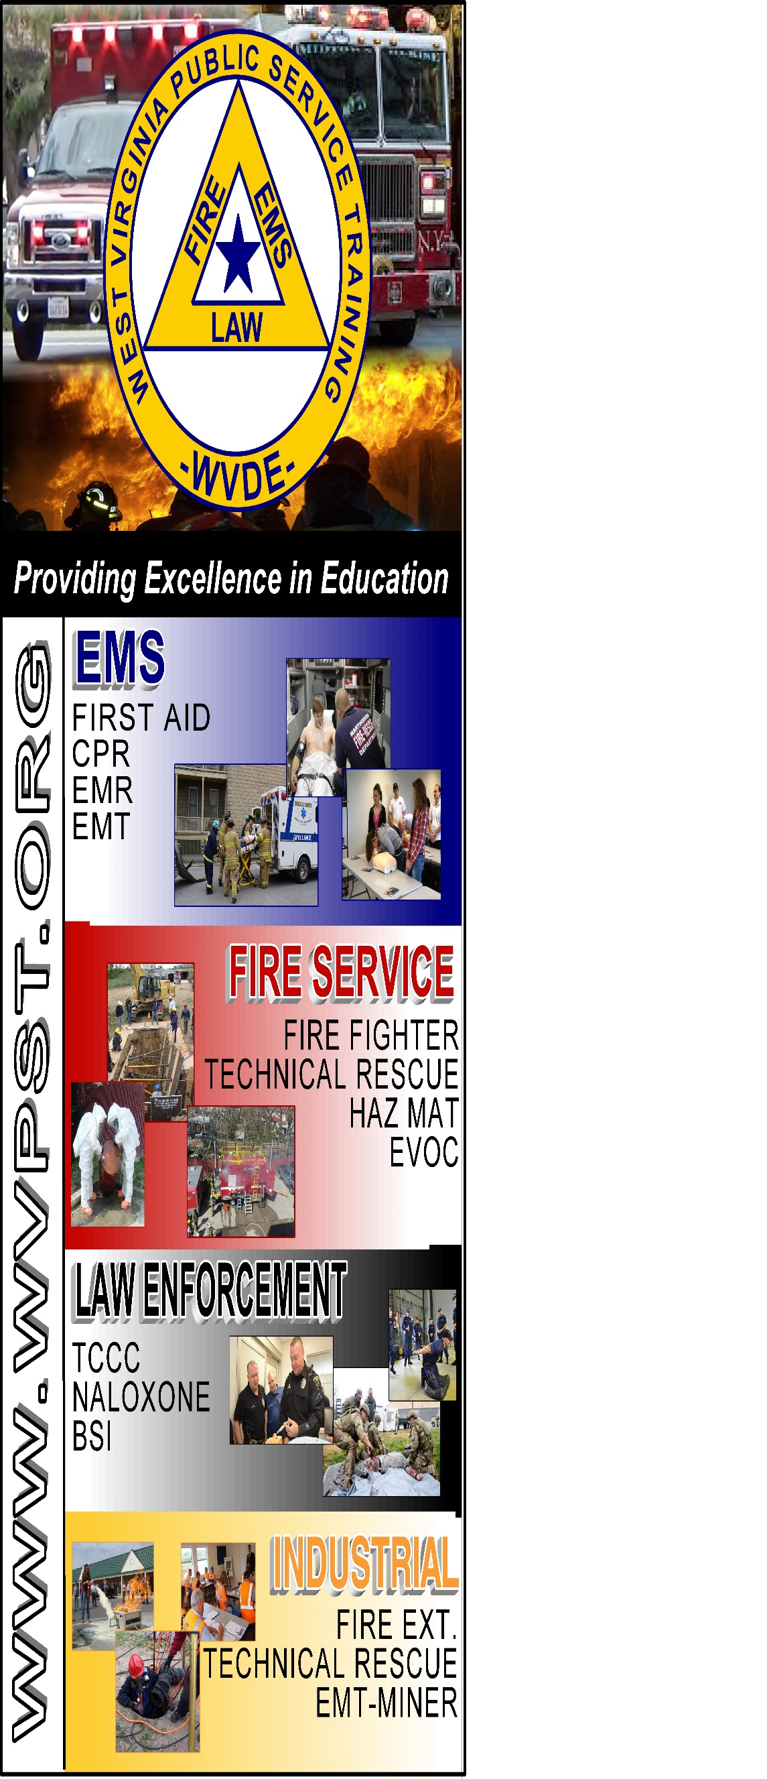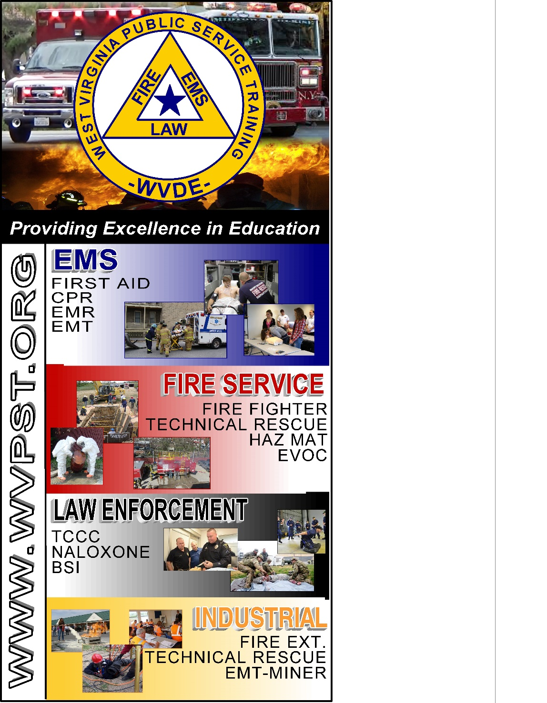

**WVPST COURSE OFFERING**

**Emergency Vehicle Operators Course**

**LOCATION: Middleway VFC  
  
CLASS DATES: May 14 – 8am-4pm**

**May 15 – 8am-4pm**

**INSTRUCTOR: Steven Harris   
  
HOURS: 16**

***Prerequisites: Must be 18 years old and hold a Valid Driver’s License***

**CLASS COST: $35.00  
BOOK Rental: $10.00  
*(All students are required to have a book)***

**Pre-registration required online at** [**www.wvpst.org**](http://www.wvpst.org)**. Select Martinsburg and click on the class in the calendar. Minimum of 15 students required.**

**Contact WVPST at 304-267-3595 ext. 116**