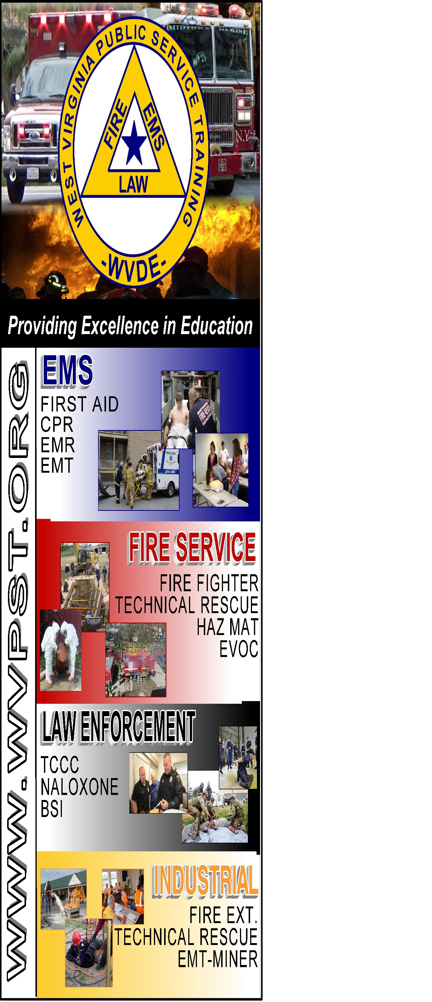

**WVPST COURSE OFFERING**

**MCI**

**Refresher**

**LOCATION: Burlington VFC  
  
DATE: December 22  
TIME: 6pm – 8pm**

**INSTRUCTOR: Robert Haggerty  
  
HOURS: 2**

**Prerequisites: None  
CLASS COST: No Charge**

**Pre-registration is NOT required.**

**Contact WVPST at 304-267-3595 ext. 116**