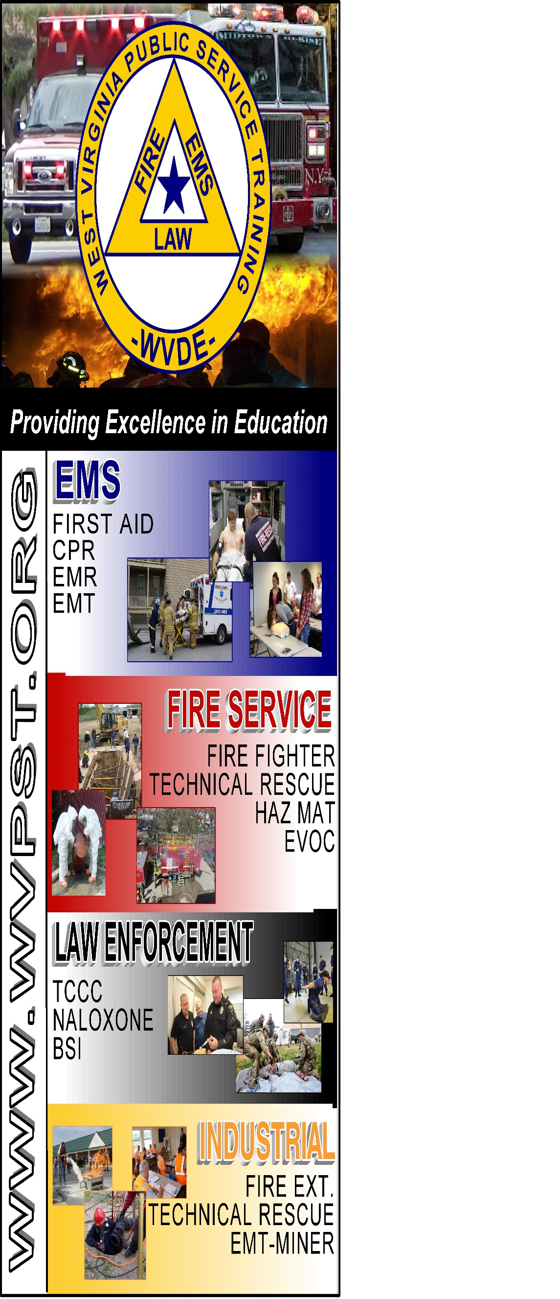

**WVPST COURSE OFFERING**

**NIMS 300**

**LOCATION: Shepherdstown VFD  
  
DATE: August 6 – 6pm-10pm**

**August 7,8 – 8am-5pm**

**INSTRUCTOR: Dr. Mike Athey  
  
HOURS: 18**

**Prerequisites: NIMS 100 and 200  
*Students are required to bring a laptop for class*  
  
CLASS COST: $35.00**

**MATERIAL COST: $10.00**

**Pre-registration required online at** [**www.wvpst.org**](http://www.wvpst.org)**. Select Martinsburg and click on the class in the calendar. Minimum of 15 students required.**

**Contact WVPST at 304-267-3595 ext. 116**