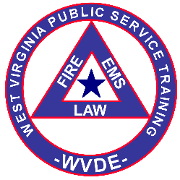
WV Public Service Training

Student Grievance/Suggestion Form

Purpose of this form This form allows a student enrolled in a WV Public Service Training Program to submit a written record of any concern or suggestion. It is recommended that the student first informally approach either the course instructor or the WV Public Service Training Coordinator to discuss the issue. Most issues can be resolved without formal written procedures, but this form can be used if the student is not satisfied with the initial informal response to a concern. This form can be submitted to the course instructor or the WV PST Coordinator. The form will be scanned into the course folder for recordkeeping. Students and Instructors can maintain a copy of this completed form.

Printed Name of Student
Signature of Student Date signed
WVPST Course name and location.
WVPST Course Number (if assigned at the time this form is completed)
Date this form was completed
Provide details of the Concern or Suggestion Continue on the back of this form or attach additional sheets if necessary. Other documentation can be attached.

Printed Name of Course Instructor
Signature of Instructor Date signed
(The instructor should sign upon receipt if this form is submitted to the instructor. If submitted directly to the PST Coordinator the form will be signed by the instructor when reviewed with the PST Coordinator)
Signature of PST Coordinator Date signed
Check here if this is a follow-up to a previous form.

