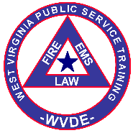
Firefighter 1 and 2 Tally Sheet
FF 1 Course Number: -08 HazMat Aw/Ops Course Number: -08 FF 2 Course Number: -08
Location: Instructor:
 | Name | FF 1 | FF 1 Test | CPR  FA | Live  Burn | HazMat Aw/Ops | HazMat Aw/Ops Test | FF 2 | FF 2  Test | HazMat Aw/Ops Certificate Issued | FF 1  Certificate Issued | FF 2  Certificate Issued | Notes
1
2
3
4
5
6
7
8
9
10
11
12
13
14
15
16
17
18
19
20
21
22
23
24
25
An X in FF 1, HazMat Aw/Ops, and FF2 column indicates the participant met the 90% attendance rule and passed practical skills evaluations. P or F with the test score is listed in the test columns. An X in CPR FA column indicates the participant had a current CPR and First Aid card at the conclusion of the course. An X or date in the Live Burn column indicates the participant completed live burn training.
Updated xx-xx-20xx

